Ean Masoner Module 4.2 Assignment

Original Flowchart model for Sitka. Weather

Process flow after changes:

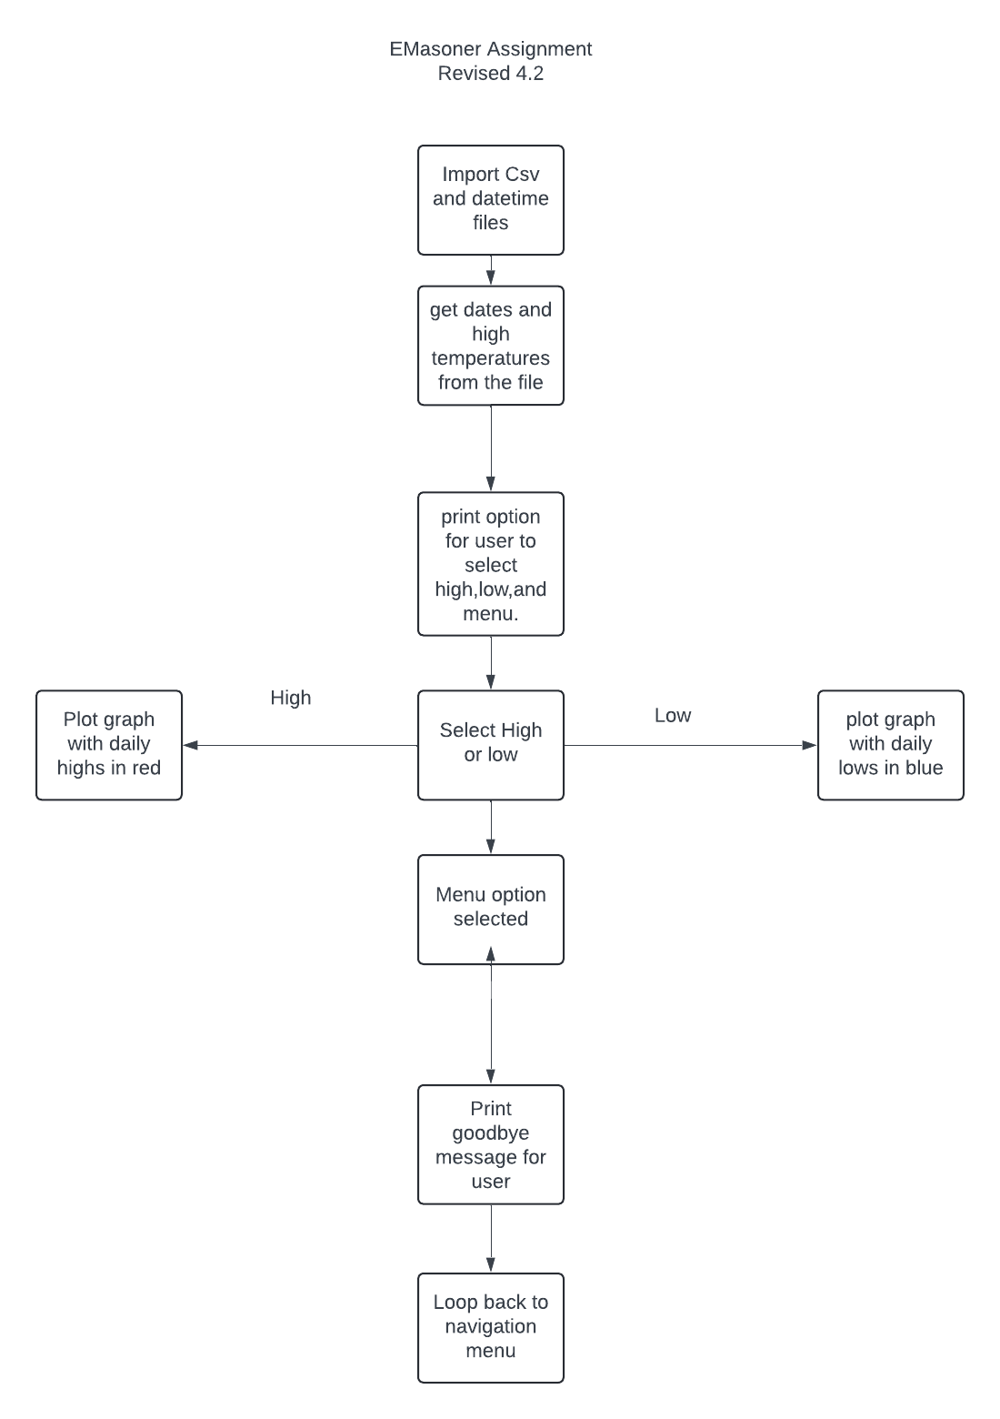hanges: